Testing cameras and spectrometers.
Note: these programs are for testing the system. They are not ment to be run with the other examples in the toolkit.

- First run RS Config and make sure all camera are listed then press Done:

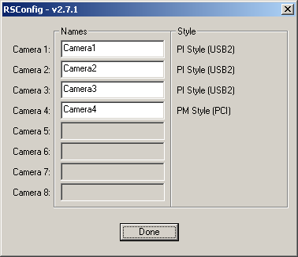

- From the run menu open pvcam.ini

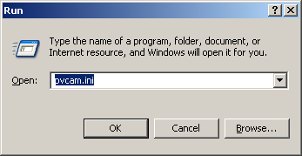

- Verify each camera has an ID (needed for USB cameras)

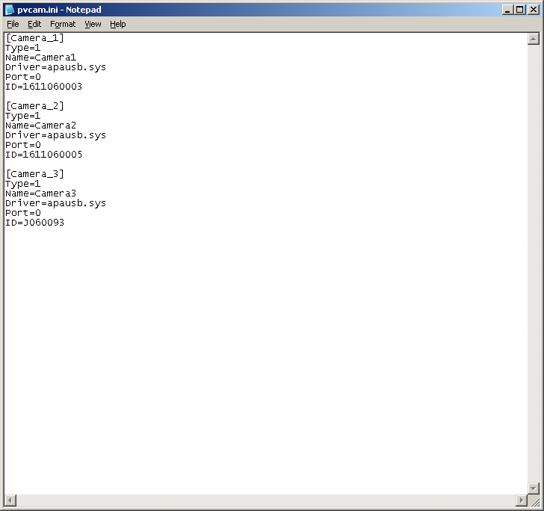

- First run ExInitTestGlobal.vi, this sets up the number of cameras and spectrometers you are going to attempt to run. You should put in the total number of cameras and spectrometer you have attached to the system here. This program will not try to open these, but only setup global arrays for other VI’s to use. It also initiates the toolkit.
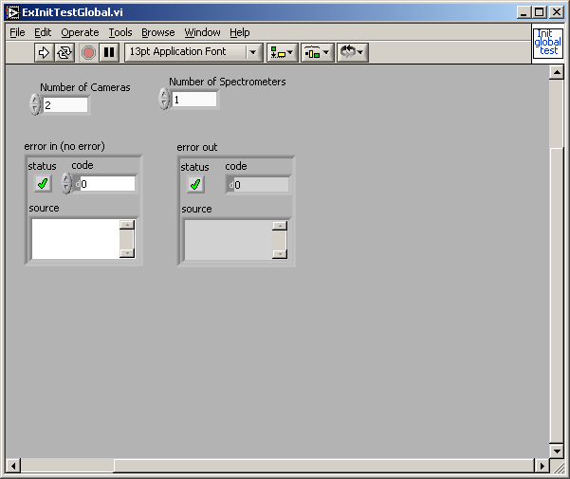

- To test cameras and run them one at a time open the program ExOpenCamTestGlobal.vi. This program allows cameras to be opened one at a time and keeps them open. Each time you open a camera you will get an led lit if it opens successfully.
- 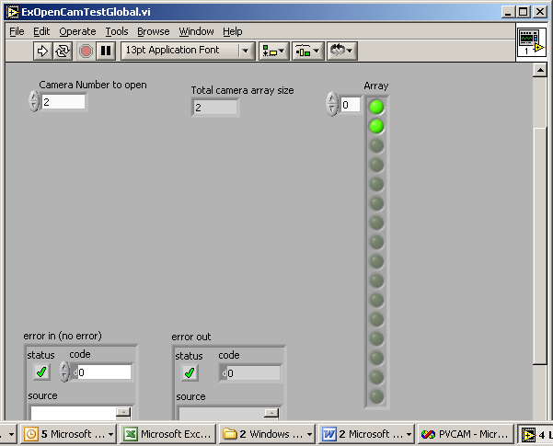

- To test spectrometer open the program ExOpenSpectTestGlobal.vi This program allows spectrometers to be opened one at a time. And keeps them opened. Every time you open a spectrometer successfully it will lite a led.
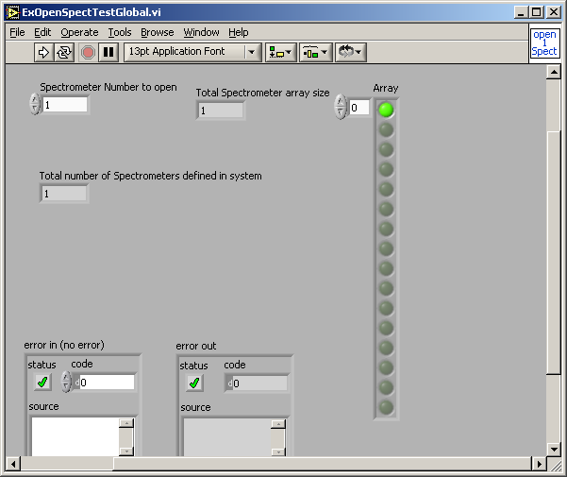

- ExTestInfoGlbMult.vi will move selected spectrometers
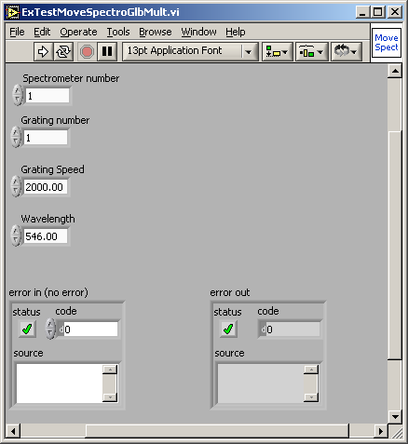

- ExTestInfoGlbMult.vi will display current information for spectrometer
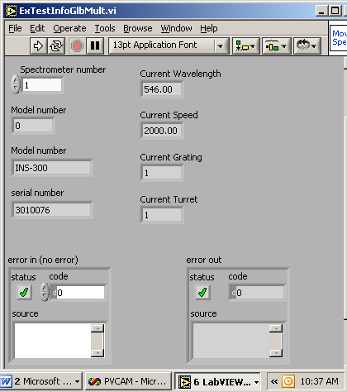

- Collect strip for each camera separately first, use the ExTestXCamSameGraph.vi

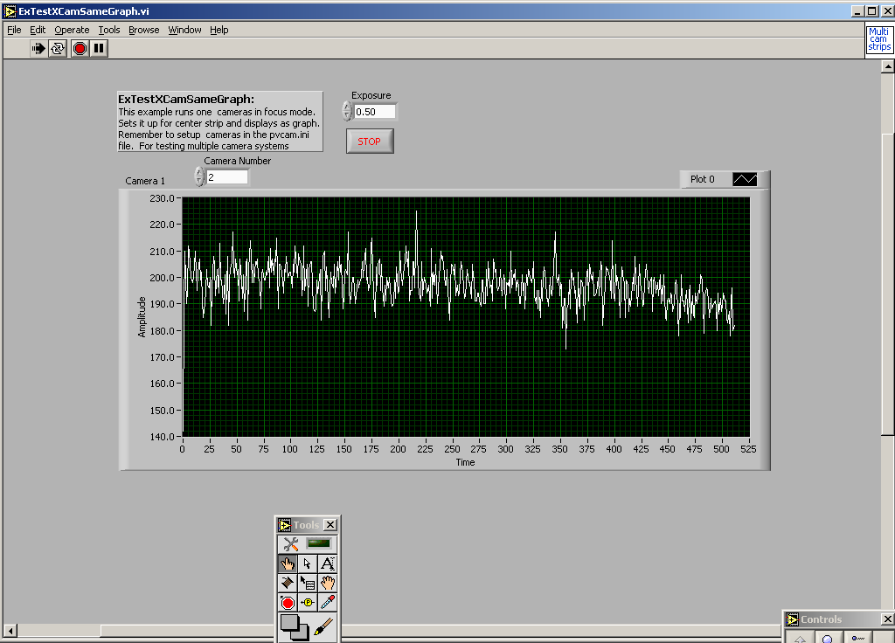

- Collect images for each camera separately, use ExTestXCamSameImage.vi

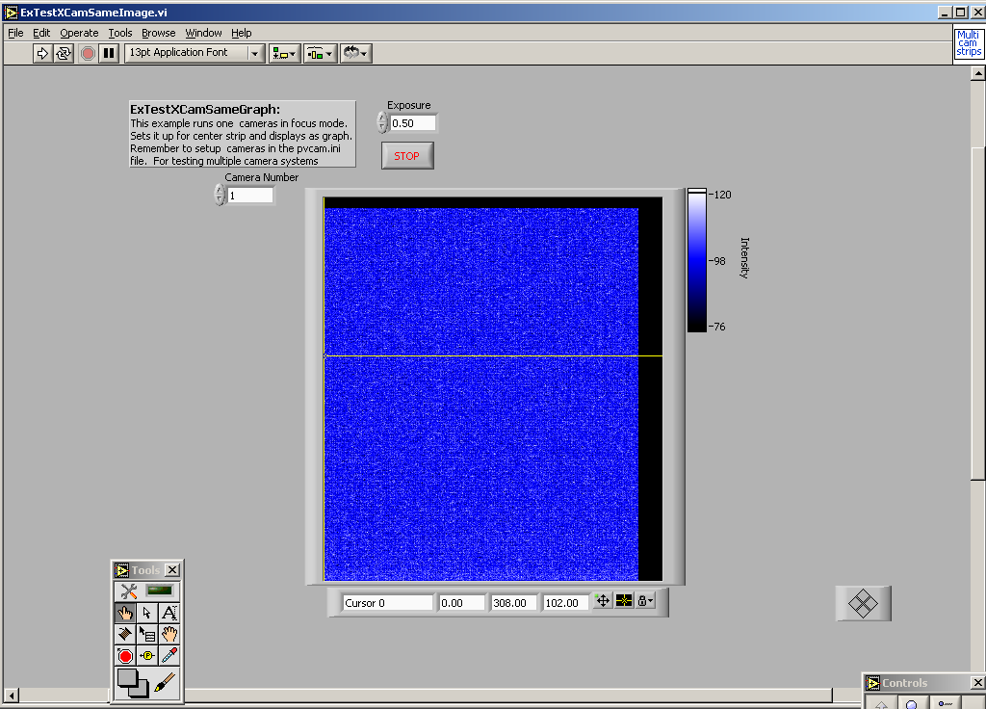

- Collecting n strips all at once, please use ExGlobalXCamSameGraph.vi

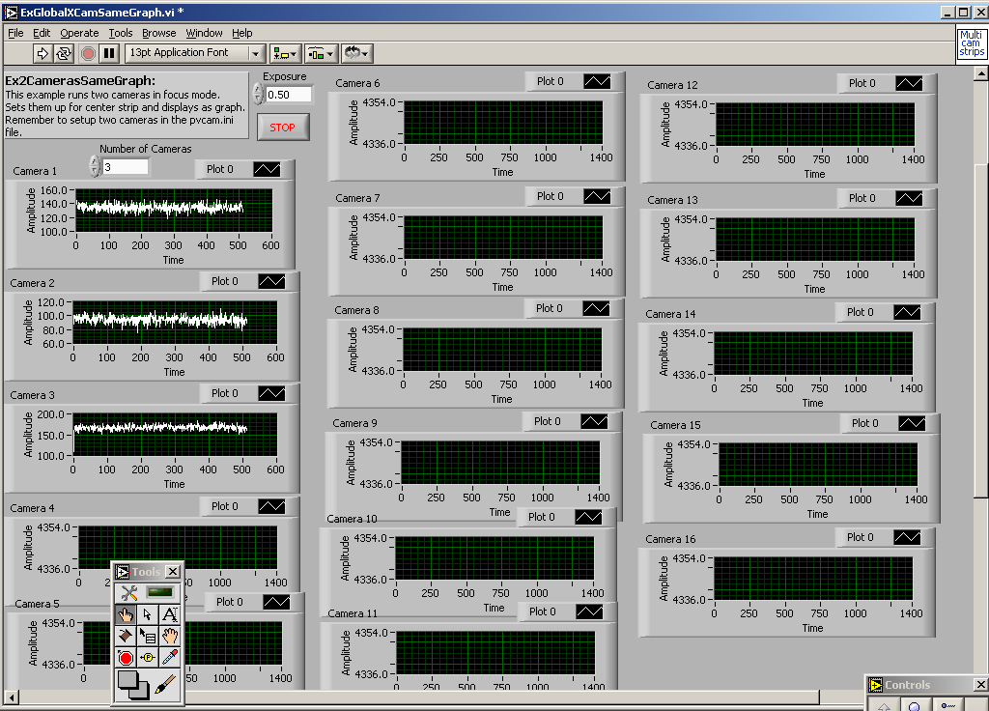

- Collecting n images at once please use ExTestAllXCamSameImage.vi

